Name-Anand Raj
Roll no.-25scs1003005435

java -version& javac -version

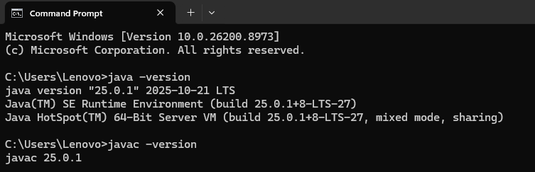

Q1. What is JDK?

Answer:
JDK (Java Development Kit) is a software development kit used to develop Java applications. It includes the JRE, Java compiler (javac), debugger, and other tools required to write, compile, and run Java programs.

Q2. What is JVM?

Answer:
JVM (Java Virtual Machine) is a virtual machine that executes Java bytecode. It makes Java platform-independent by allowing the same program to run on different operating systems.

Q3. What is JRE?

Answer:
JRE (Java Runtime Environment) is the software required to run Java applications. It includes the JVM and necessary libraries but does not contain development tools like the Java compiler.

Q4. Difference between JDK, JRE, and JVM?

Answer:
JDK | JRE | JVM
JDK stands for Java Development Kit. | JRE stands for Java Runtime Environment. | JVM stands for Java Virtual Machine.
Used to develop and run Java programs. | Used only to run Java programs. | Executes Java bytecode.
Includes JRE, compiler, debugger, and development tools. | Includes JVM and required libraries. | Part of the JRE.
Required by Java developers. | Required by users who only run Java applications. | Converts bytecode into machine code for execution.

